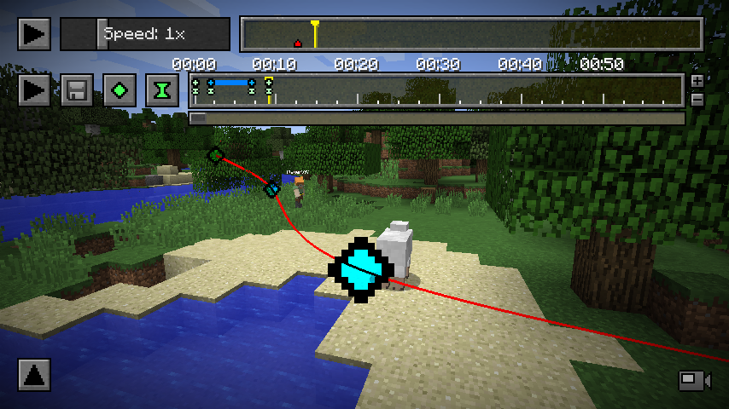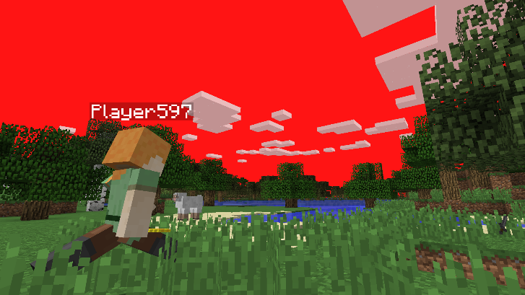

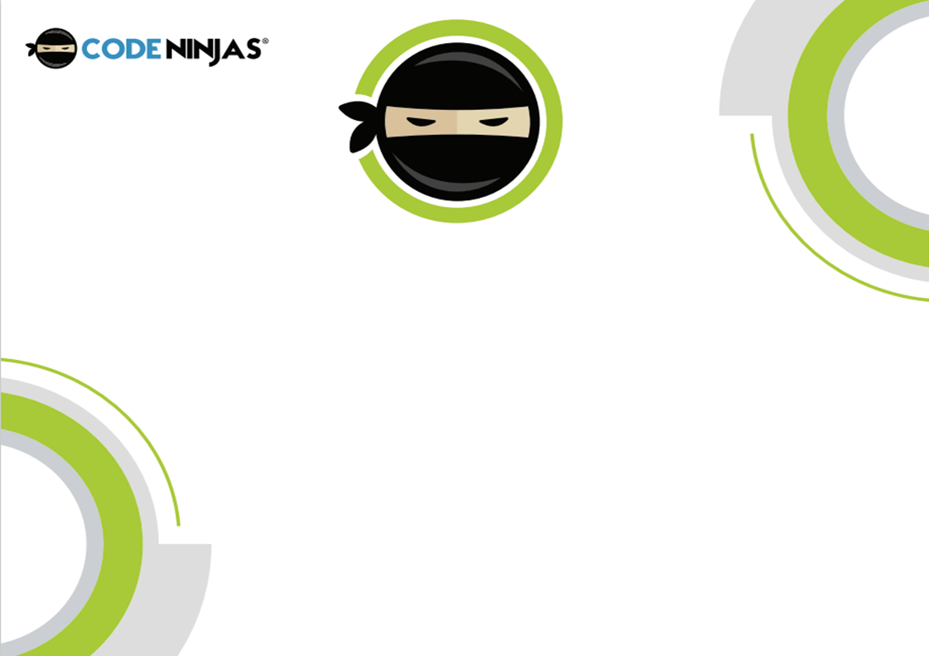



Hello Dan!

Welcome to the Code Ninjas Storytelling Camp! In +CHILDNAME+’s first session, +heshe+ got introduced into how to record & export Minecraft replays in a professional and clean manner.

To start with, +CHILDNAME+ was tasked with loading into a custom made Minecraft theme park map. Once loaded properly, +CHILDNAME+ had some time to explore and find their 3 favorite rides/attractions! Then we started recording! For now the video length was going to be under 90 seconds, so +heshe+ had to record the best bits! The recording process at this stage is relatively simple, press record when we want to record, and pause when we are moving between attractions.

Once +CHILDNAME+ finished their recording, it was into the editor! The recording works by making a new map, which +CHILDNAME+ then loads into. This new map allows +CHILDNAME+ to fly around and place the camera wherever +heshe+ would like it, as well as what time in the recording +heshe+ would like the camera there. This software is superb for +CHILDNAME+ to use and +heshe+ will be getting to grips with all of its functionality allowing for time manipulation, camera snapping and so much more all throughout their sessions. This software is quite complicated to get to grips with but once it has been mastered +CHILDNAME+ will be able to make brilliant looking videos in Minecraft easily!

Once +CHILDNAME+ had entered all the correct time & position ‘Keyframes’ and tested their video a few times to smooth out their transitions, they exported their video to watch! Fantastic work Ninja!



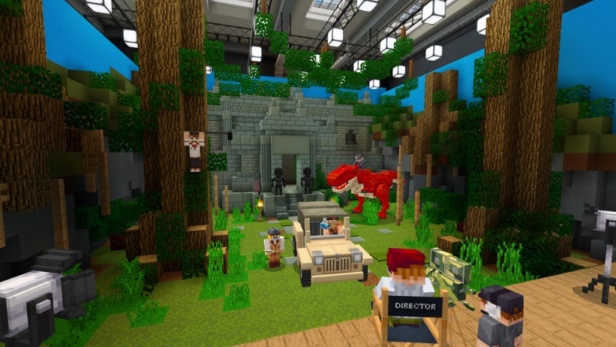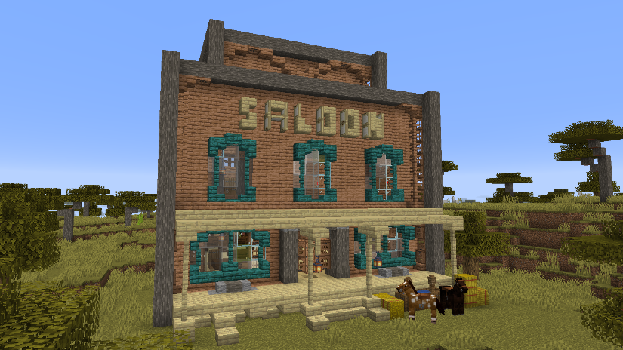





What good is a story without a place to tell it!? Today +CHILDNAME+ kicked off +hisher+ session creating the set of their recording!

Since getting to grips with our replay editor, +CHILDNAME+ has learned how to move around the camera in space and time to allow for professional looking transitions and camera movements without too much complexity. Now +CHILDNAME+ has to plan out and build their set for their story they will be telling. For some Ninjas, the story is the building of the set itself, for example a story of a stranded survivor building a shelter to live in, so the recording would need lots of smaller sections cut together in a montage of the creation over time.

For most Ninjas the story will take place in their set, for example a tavern brawl in the local Western Saloon! For both types of story, planning is key. To avoid having to go back to the drawing board and restasting the creations, it is essential that we plan the creations with +CHILDNAME+ so +heshe+ has a clear goal of what their final story’s set will look like. After making the plan of the set and stroy, +CHILDNAME+ got to work!

Many Ninjas are somewhat used to creating in Minecraft, but not many have planned their creations before making them! This helps develop +CHILDNAME+’s creative skills and shows +himher+ how useful planning can be to creating projects. Taking inspiration from other Ninjas is something we always recommend and foster in our Dojo, having +CHILDNAME+ stand up and walk around other Ninjas creations having them each share what they have made to others!

Brilliant work +CHILDNAME+! Very well done for planning, creating and sharing your set today!